Scope
Supplier | Test | Client | Test
Contracts | Test
Description | Test
Period | 01 March 2021 - 30 April 2021 | Billings | Test AUD
Status | Test Report

Test

Dear ,

Test (Test)

Test.
Test

Unsubstantiated Charges (USD)
Number | Description of Finding | Preliminary Finding | Final Supplier Response | Finding for Reimbursement
Total |  | PREL_FINDING_TOTA11L | SUPPLIER_RESPONSE_TOTAL1 | REIM_FINDING_TOT1AL

Test
Test

test

Regards,

auditReport.clientContact1  auditReport.clientContactTitle1  Test (Client) | auditReport.contac1t  auditReport.contactTitle1

Unsubstantiated Charges # U-A-7
Amount | 100.00 USD | Includes tax | No | Extrapolation

Description
ter the border was defined so to make the northern portion of the territory concerned part of the French mandated territory that became Lebanon, many Zionist geographers — and Israeli geographers in the state's early years — continued to speak of "The Upper Galilee" as being "the northern sub-area of the Galilee region of Israel and Lebanon".
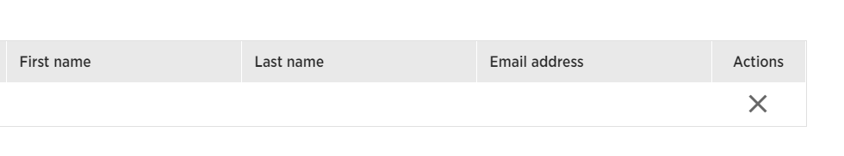
Under this definition, "The Upper Galilee" covers an area spreading over 1,500 km², about 700 in Israel and the rest in Lebanon. This included the highland region of Belad Bechara in Jabal Amel located in South Lebanon,[4]
Attachments (if any)

FINAL SUPPLIER RESPONSE
Response
Final response |  | Agree |  | Partially agree |  |  |  | Disagree
Response date |  |  |  |  |  | Reimbursement amount

Description
Attachments (if any)

