Header :
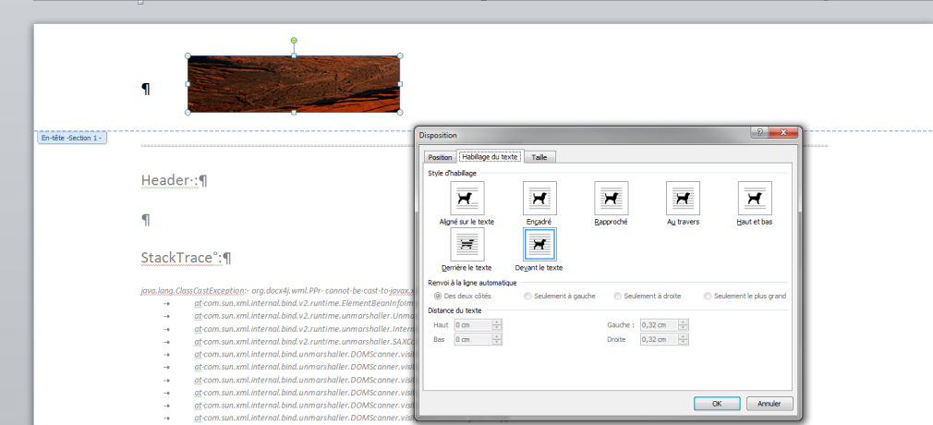
StackTrace :
java.lang.ClassCastException: org.docx4j.wml.PPr cannot be cast to javax.xml.bind.JAXBElement
at com.sun.xml.internal.bind.v2.runtime.ElementBeanInfoImpl$IntercepterLoader.intercept(ElementBeanInfoImpl.java:230)
at com.sun.xml.internal.bind.v2.runtime.unmarshaller.UnmarshallingContext.endElement(UnmarshallingContext.java:505)
at com.sun.xml.internal.bind.v2.runtime.unmarshaller.InterningXmlVisitor.endElement(InterningXmlVisitor.java:66)
at com.sun.xml.internal.bind.v2.runtime.unmarshaller.SAXConnector.endElement(SAXConnector.java:145)
at com.sun.xml.internal.bind.unmarshaller.DOMScanner.visit(DOMScanner.java:239)
at com.sun.xml.internal.bind.unmarshaller.DOMScanner.visit(DOMScanner.java:265)
at com.sun.xml.internal.bind.unmarshaller.DOMScanner.visit(DOMScanner.java:234)
at com.sun.xml.internal.bind.unmarshaller.DOMScanner.visit(DOMScanner.java:265)
at com.sun.xml.internal.bind.unmarshaller.DOMScanner.visit(DOMScanner.java:234)
at com.sun.xml.internal.bind.unmarshaller.DOMScanner.visit(DOMScanner.java:265)
at com.sun.xml.internal.bind.unmarshaller.DOMScanner.visit(DOMScanner.java:234)
at com.sun.xml.internal.bind.unmarshaller.DOMScanner.scan(DOMScanner.java:111)
at com.sun.xml.internal.bind.unmarshaller.DOMScanner.scan(DOMScanner.java:94)
at com.sun.xml.internal.bind.unmarshaller.DOMScanner.scan(DOMScanner.java:87)
at com.sun.xml.internal.bind.v2.runtime.BinderImpl.associativeUnmarshal(BinderImpl.java:145)
at com.sun.xml.internal.bind.v2.runtime.BinderImpl.unmarshal(BinderImpl.java:116)
at org.docx4j.openpackaging.parts.WordprocessingML.HeaderPart.unmarshal(HeaderPart.java:197)
at org.docx4j.openpackaging.parts.WordprocessingML.HeaderPart.unmarshal(HeaderPart.java:48)
at org.docx4j.openpackaging.io.LoadFromZipNG.getRawPart(LoadFromZipNG.java:551)
at org.docx4j.openpackaging.io.LoadFromZipNG.getPart(LoadFromZipNG.java:427)
at org.docx4j.openpackaging.io.LoadFromZipNG.addPartsFromRelationships(LoadFromZipNG.java:350)
at org.docx4j.openpackaging.io.LoadFromZipNG.getPart(LoadFromZipNG.java:449)
at org.docx4j.openpackaging.io.LoadFromZipNG.addPartsFromRelationships(LoadFromZipNG.java:350)
at org.docx4j.openpackaging.io.LoadFromZipNG.process(LoadFromZipNG.java:243)
at org.docx4j.openpackaging.io.LoadFromZipNG.get(LoadFromZipNG.java:193)
at org.docx4j.openpackaging.packages.OpcPackage.load(OpcPackage.java:225)
at org.docx4j.openpackaging.packages.OpcPackage.load(OpcPackage.java:177)

