TEMPLATE_TITLE | sdf
TEMPLATE_REFERENCE | df
TEMPLATE_AUTHOR | QBMUSER

QUESTION_TYPE | READING_COMPREHENSION
QUESTION_TOPIC | New-ww_16
QUESTION_ID | Q1
CHILD_QUESTIONS | 1
QUESTION_TEXT | 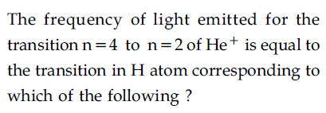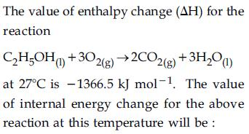
DIFFICULTY_LEVEL | UNDEFINED

QUESTION_TYPE | MULTIPLE_CHOICE_QUESTION
QUESTION_TOPIC | New-ww_16
QUESTION_ID | Q2
PARENT_PASSAGE_ID | Q1
QUESTION_TEXT | 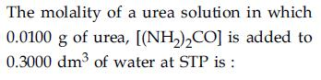
NUMBER_OF_OPTIONS | 2
1 | 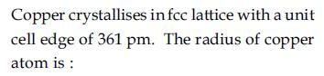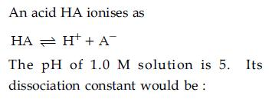
2 | 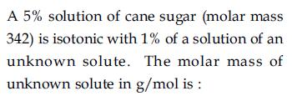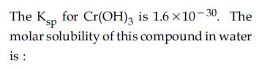
CORRECT_ANSWER
DIFFICULTY_LEVEL | PARENT LEVEL

