[[expression6]]

[[indicator0]]

[[indicator7]]

[[expression11]]

[[expression12]]

[[expression13]]

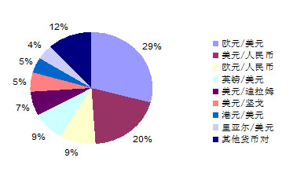

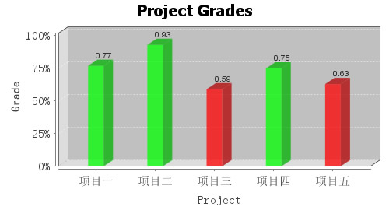

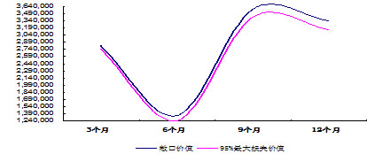

测试测试