This document uses a basic set of Word features; you can look at the WordML to see how those features are stored.
This is an unstyled paragraph.

This is style Heading 1

Left indent
Centre
Align Right
Justified text

Indented

First line indent, Left indent, Hanging indent aaa bbb aaa bbb aaa bbb aaa bbb aaa bbb aaa bbb aaa bbb aaa bbb aaa bbb aaa bbb aaa bbb aaa bbb aaa bbb aaa bbb

Tabbed

Normal
A parapgraph with 10 points spacing before, 20 points after.
Normal

Font styles Aerial Black
Font styles 18 point
Font styles bold
Font styles italic
Font styles underline
Font styles strikeout
Font styles colour
Font styles example

Bullets
- Level 1
  - Level 2

Numbering
- Level 1
  - Level 2
    - Level 3

Here is some change tracking. An insertion Followed by.

This line contains a soft return
and here it continues…

A cross reference: 1)

Jpeg:
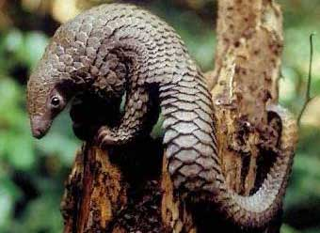

Gif (scaled):
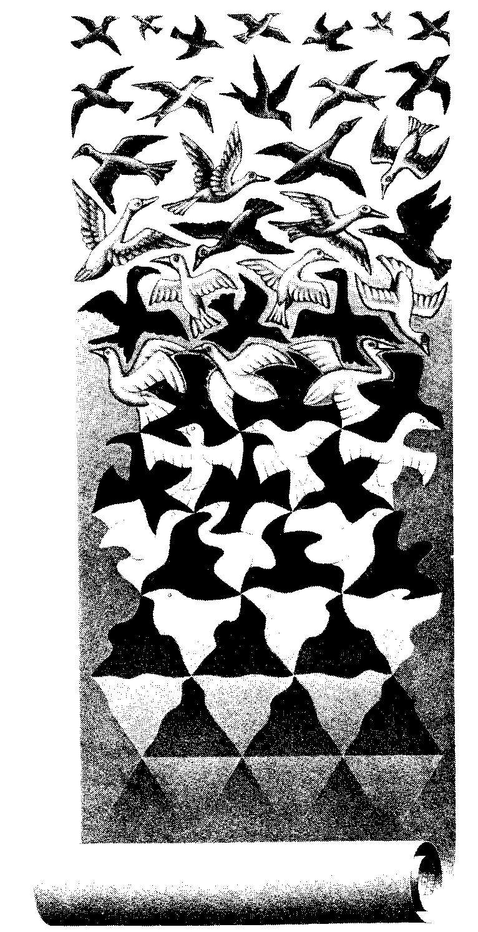

Png (from http://davidpritchard.org/images/pacsoc-s1b.png )
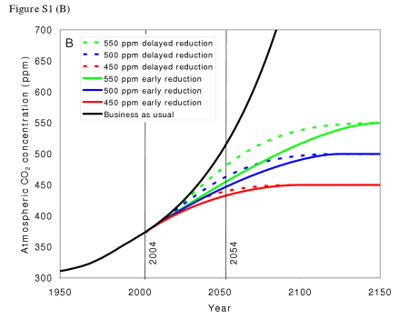

That was a page break

Finally, a table:

Cell text |  | Shaded grey
Vertical merge |  | Shaded grey
 | Horizontal merge

We should also have a content control in here (sdt):
This is a rich text content control.

