Docx sample document
This is a document exhibiting basic docx features.

This is style Heading 1

Some text.

Tables

Cell text |  | Shaded grey
Vertical merge |  | Shaded grey
 | Horizontal merge

(There is another document which tests tables more thoroughly)

Paragraph properties

Left indent
Centred
Align Right
Justified text

Indented indented indented indented indented indented indented indented indented indented indented indented indented indented indented indented indented indented indented indented

First line indent, Left indent, Hanging indent aaa bbb aaa bbb aaa bbb aaa bbb aaa bbb aaa bbb aaa bbb aaa bbb aaa bbb aaa bbb aaa bbb aaa bbb aaa bbb aaa bbb

Normal
A short paragraph with 10 points spacing before, 20 points after.

Run properties

Font styles Aerial Black
Font styles 18 point
Font styles bold
Font styles italic
Font styles underline

Bullets & numbering

Bullets
- Level 1
  - Level 2

Numbering
- Level 1
  - Level 2
    - Level 3

Images

Jpeg:
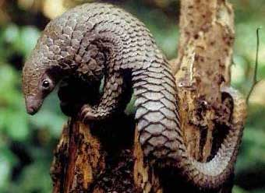

Gif (scaled):
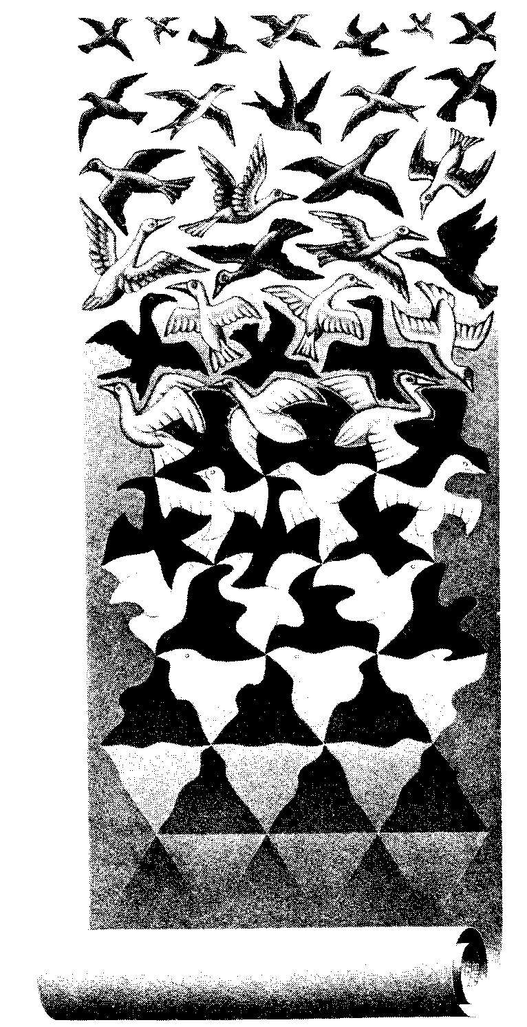

Png (from http://davidpritchard.org/images/pacsoc-s1b.png )
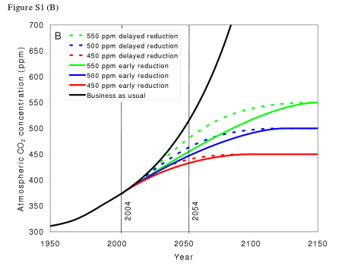

(TODO: we really should have both 2003 & 2007 pictures)

That was a page break

Here is some change tracking. An insertion Followed by.

This line contains a soft return
and here it continues

